SUNSCREEN CONSENT FORM
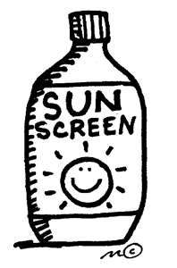
Childs Name Date of Birth

As the parent/guardian of the above child, I recognize that too much exposure to UV rays may increase my child’s risk of getting skin cancer someday. Therefore, I give permission for the staff at the Children's Journey Center to apply a sunscreen product that I provide for my child when he/she will be playing outside. I understand that sunscreens will be applied to exposed skin approximately 20-30 minutes before going outside, including but not limited to the face (except eyelids), tops of ears, nose, bare shoulders, arms and legs.
I have checked and initialed below all applicable information regarding the child care program’s use of sunscreen for my child:
- I do not know of any allergies my child has to sunscreen
- For medical or other reasons, please do NOT apply sunscreen to the following areas of my child’s body:

Parent/Guardian’s Name:

Parent/Guardian’s Signature: Date:

** This consent must be renewed each year.

